Homework 3  
Statistical Inference

**PREPARED BY**

Mohsen Fayyaz - 810100524

Fall 2021

**فهرست مطالب**

**Q1** **3**

For each following statement, determine if there is any problem fix it. 3

**Q2** **6**

A student visits her doctor with concerns about being infected by covid-19. If the forehead temperature exceeds 38.2°C, the person is suspected that infected with the coronavirus. A patient’s forehead temperature measure often has a considerable variation during a given day. Suppose an adult’s forehead temperature measures during a given day has a normal distribution with a mean of 37.1°C and a standard deviation of 0.5°C. 6

**Q3** **8**

**Q4** **9**

**Q5** **9**

**Q6** **10**

**Q7** **12**

**Q8** **13**

**Q9** **15**

(R) According to the patient image dataset1, answer the following questions: 15

[**X -> went_icuYes (Y) if the patient was in the ICU (intensive care unit) or CCU (critical care unit) at any point during this illness or No (N) or  
Y -> survivalYes (Y) or no (N) or blank if unknown**](#_wq2mi9yjnogm) **18**

**Q10** **20**

(R) According to Exercise 7, we are ambiguous about the actual value between 9,10,11,12,13, but we know 𝜎=0.7. Answer the following questions by computing power. 20

**Q11** **23**

(Bonus) Answer the following question: 23

# Q1

## For each following statement, determine if there is any problem fix it.

a. In the CLT we are looking for a confidence interval for the sample mean

False: In CLT (Central Limit Theorem) we are looking for the distribution of the sample mean, approximated by a normal model.

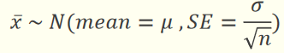

b. With the same null hypothesis, it’s always possible that we reject 2 side tests while 1 side test doesn’t reject.

False: It is the opposite. We reject when the p-value is small. Hence, when we have one side tests we have less p-value than two side tests and we may be able to reject in one side but not in two side.

c. The central limit theorem states that the sampling distribution of sample means will closely resemble the normal distribution regardless of the sample size.

False: Certain conditions must be met for the CLT to apply:  
1. Independence: random sampling and 𝑛 < 10% of the population  
2. Sample size/skew: moderately skewed $⇒$ 𝑛 > 30  
Hence, there are both n<10% and n>30 conditions on sample size (in certain scenarios)

d. For a positively skewed distribution, the mean usually has a larger value than either the median or the mode.

True: the mean is greater than the median and the mode as the data is more towards the lower side  
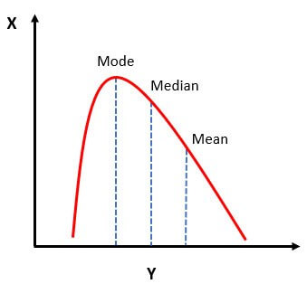

e. For a given standard error, lower confidence levels produce wider confidence intervals.

False: higher confidence levels produce wider confidence intervals (CL↑ width↑)

f. The statement, “the 95% confidence interval for the population mean is (350, 400)”, is equivalent to the statement, "there is a 95% probability that the population mean is between 350 and 400".

False: The population mean is a fixed number and is either in or out of 350 and 400. The correct statement is that 95% of random samples of this population will yield confidence intervals that contain the true population mean.

g. A 95% confidence interval obtained from a random sample of 1000 people has a better chance of containing the population percentage than a 95% confidence interval obtained from a random sample of 500 people.

False: 95% confidence interval means that we are 95% confident that the population average is between the range we computed. So this is independent of the sample size.

h. Suppose we have constructed the following confidence interval about the mean age of freshmen college students in a State: 18.4 < μ < 21.5 The proper interpretation is that we are 95% confident that the sample mean is in the range 18.4 and 21.5 years.

False: We already have the sample mean! What we try to estimate is the population mean.

i. A confidence interval is an estimate for which there is a specified degree of certainty that the population parameter will be in the interval.

True

j. The larger the difference between the actual value of the population mean and the value hypothesized, the larger beta will be.

False: Beta or type II error is when we should reject H0 but we do not. A larger difference between the population mean and the hypothesized value means a lower p-value which helps us to reject H0 with a higher probability; hence, beta (falsely not rejecting H0) decreases.

k. A researcher cannot commit type I and type II errors at the same time, on the same hypothesis test.

True (either falsely reject (I) or falsely not reject (II))

l. Even though you rejected the null hypothesis, it may still be true.

True

m. The first type of error in using a “corona thermometer test” at the public place entrance is more important than the second type of error. with the ground assumption that everyone is healthy and we are looking for people who are suspected of having the coronavirus.

False: It is the opposite of “better that ten guilty persons escape than that one innocent suffer” because it is disastrous if we let a covid positive person in a public place. Hence, here type 2 error (declaring the person healthy when they are actually sick) is more important.

# 

# Q2

## A student visits her doctor with concerns about being infected by covid-19. If the forehead temperature exceeds 38.2°C, the person is suspected that infected with the coronavirus. A patient’s forehead temperature measure often has a considerable variation during a given day. Suppose an adult’s forehead temperature measures during a given day has a normal distribution with a mean of 37.1°C and a standard deviation of 0.5°C.

a. What is the probability that a single forehead temperature measurement will fail to detect that the patient suspected coronavirus infection?

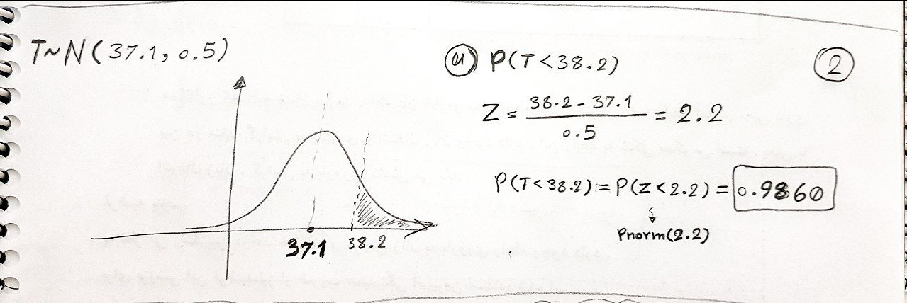

b. If five forehead temperature measurements are taken at various times during the day, what is the probability that the average of the five measurements will be less than 36.0°C and hence fail to indicate that the patient suspected coronavirus infection?

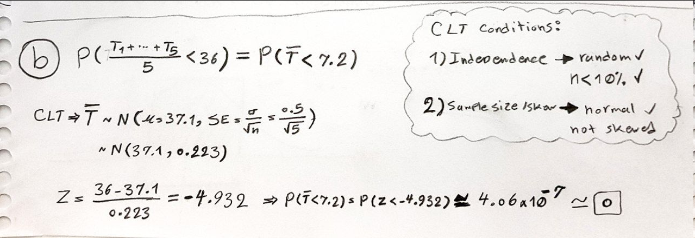

c. (R) How many measurements would be required in a given day so that there is at most 1% probability of failing to detect that the patient suspected coronavirus infection?

With 36 threshold: only 2

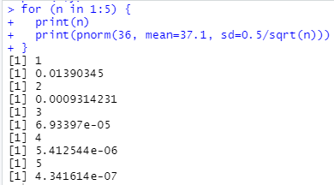

With 38.2 threshold: never

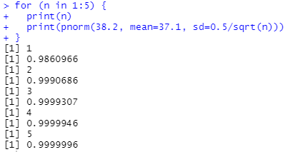

It is shown in the plot as well that for less than 38.2 we have high probability and adding more measurements will only incease it further.  
And in less than 36 case it is already very small in the first measurement and more will decrease it further.

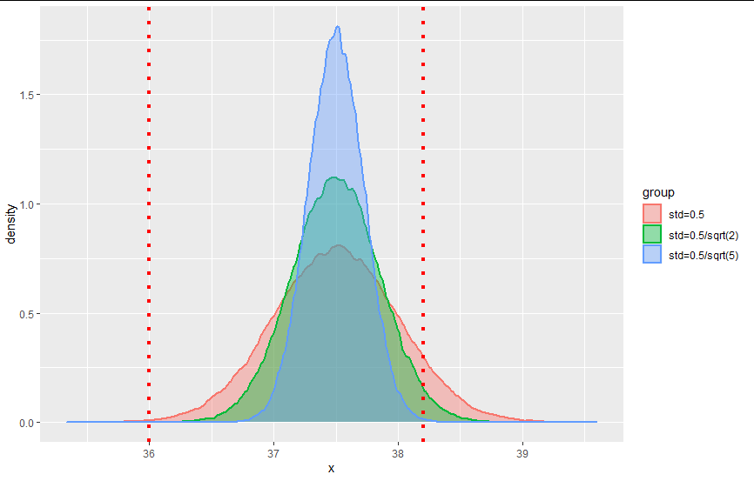

# Q3

A game of rolling 6-sided dice will be held which every person could roll one 10 times. X is the total value of all 10 dice and is equal to 𝑋1 + 𝑋2 + · · · + 𝑋10. For appointing the winner, calculate the sum of each person's total value of all 10 dice. If the person's total value is in 𝑋 ≤ 25 or 𝑋 ≥ 45, she/he will win. Use the central limit theorem to calculate the probability that each person wins. Recall that 𝐸[𝑋𝑖] = 3.5 and 𝑉𝑎𝑟(𝑋𝑖) = 35.

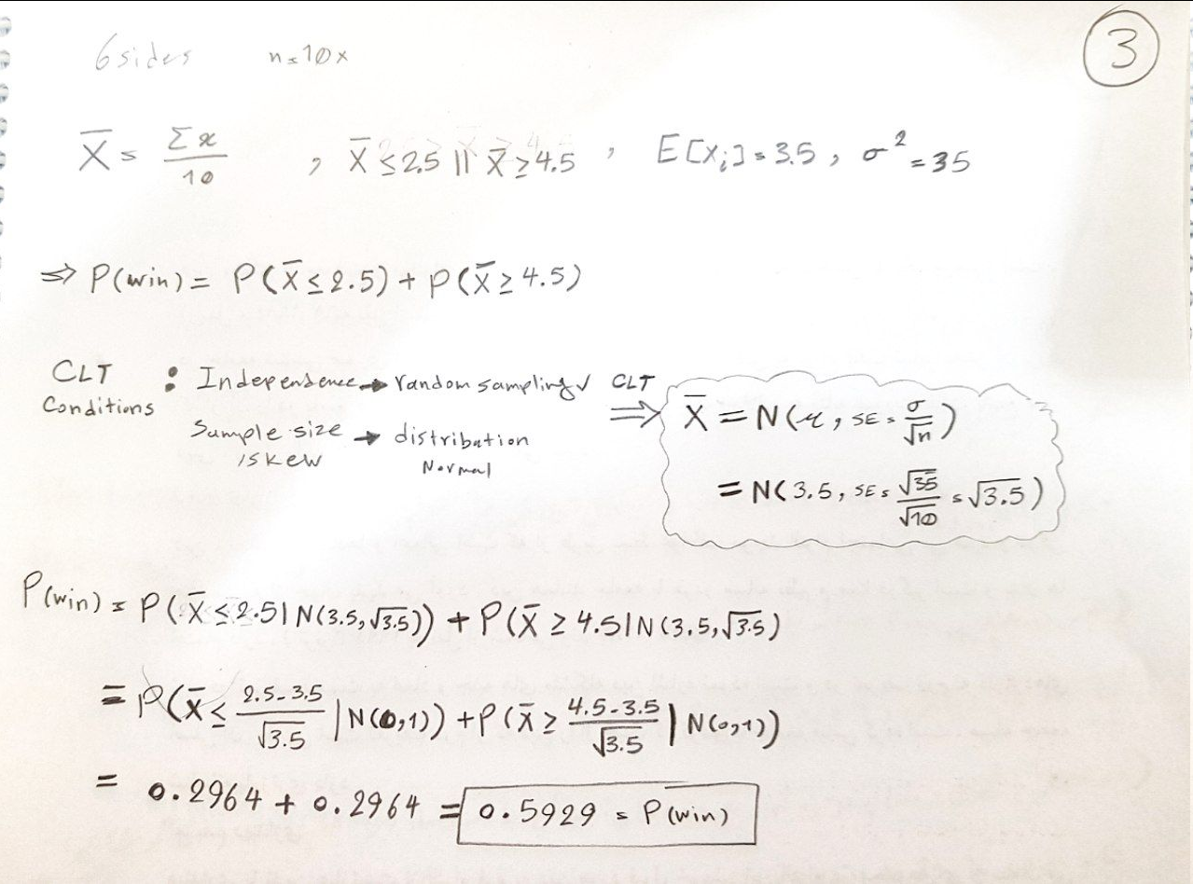

# 

# Q4

London’s mean high temperature in July is 72 ̊F with the standard deviation is 6 ̊F, while in January high temperatures average is 38 ̊F with a standard deviation of 12 ̊F. In which month is it more unusual to have a day with a high temperature of 45 ̊F? Explain.

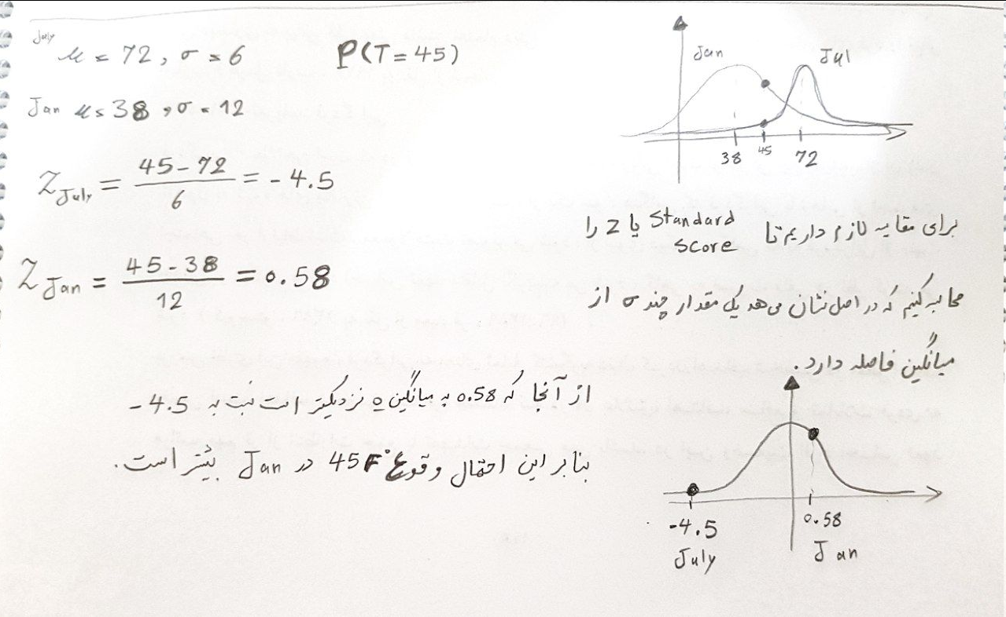

# Q5

You have a set of water bottles whose volume is known to follow a N(μ, 25) distribution. For having a 98% confidence interval for μ with width 2, how many bottles do you have to sample for their volumes?

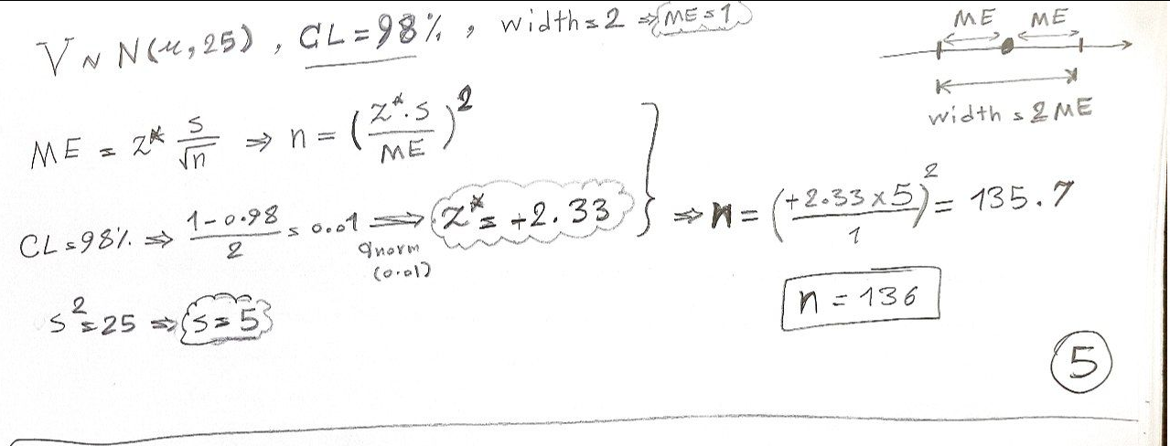

# Q6

It has been reported that the time which people spend searching, finding, and completing a purchase order at an online shopping follows a normal distribution. A research has been done with a random sample of 35 of the purchase process that gives a sample mean of 14 minutes with a sample standard deviation of 5 minutes.

a. Give a 95% confidence interval for the true average time per purchase process.

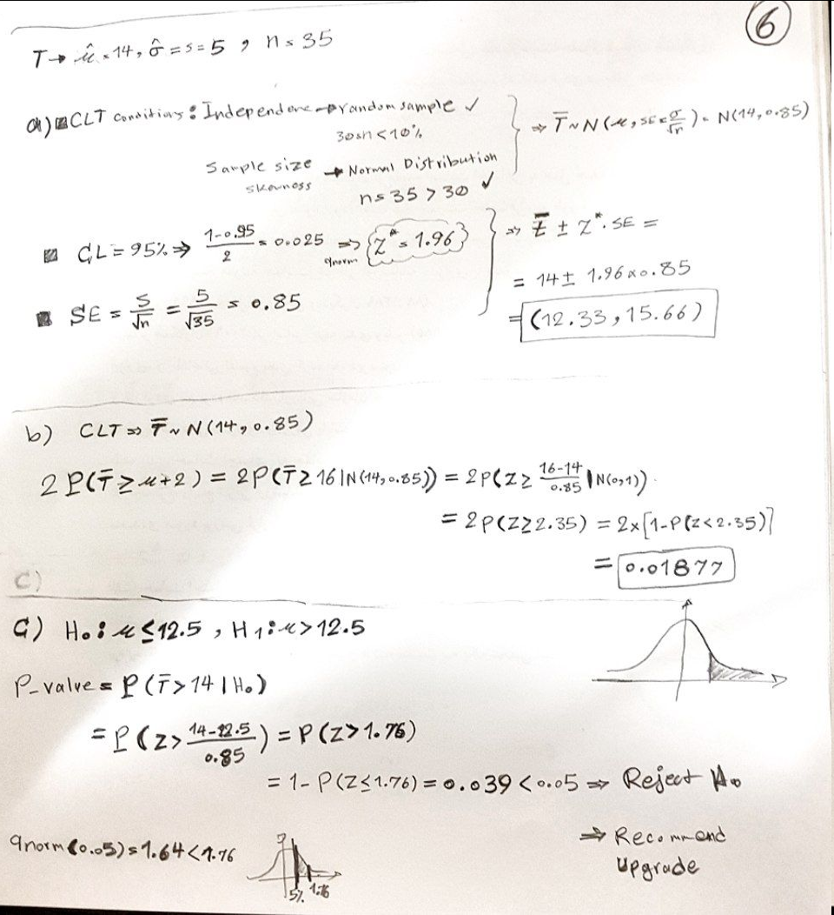

b. What is the probability that the estimate of 14 minutes differs from the true average by 2 minutes or more?



c. With the current level of communication resources for this online shopping and their projected growth over the next 8 months, the shopping store will be able to provide satisfactory service if the average purchase process time per customer is no more than 12.5 minutes. Based on the random sample of 45->35 purchase processes would you recommend that the shopping store upgrades its communication resources? (Perform a one-sided test at a 5% significance level.)



# 

# Q7

Remy Ratatouille (master chef in the “Ratatouille” animation) wishes to estimate the mean number of rejected meals reported per weekend at Gusteau's restaurant. From a sample of 50 weekends, Remy found 2 weekends with 7 occurrences, 18 weekends with 9, 16 weekends with 10, and the remainder with 11 reported occurrences. Remy wants to check whether the average number of rejected meals per weekend has changed due to the new “meal in the menu (Ratatouille)” he helped initiate last year. The average number of rejected meals per weekend before the change on the menu was 11.5.

a. Based on the information collected from Anton Ego (a cutthroat food critic), a star was added to the restaurant stars because of a change in menu. Do you agree with this rising? (Answer this question using a one-sided test at the 5% significance level – you will need to calculate the sample standard deviation of your estimate.)

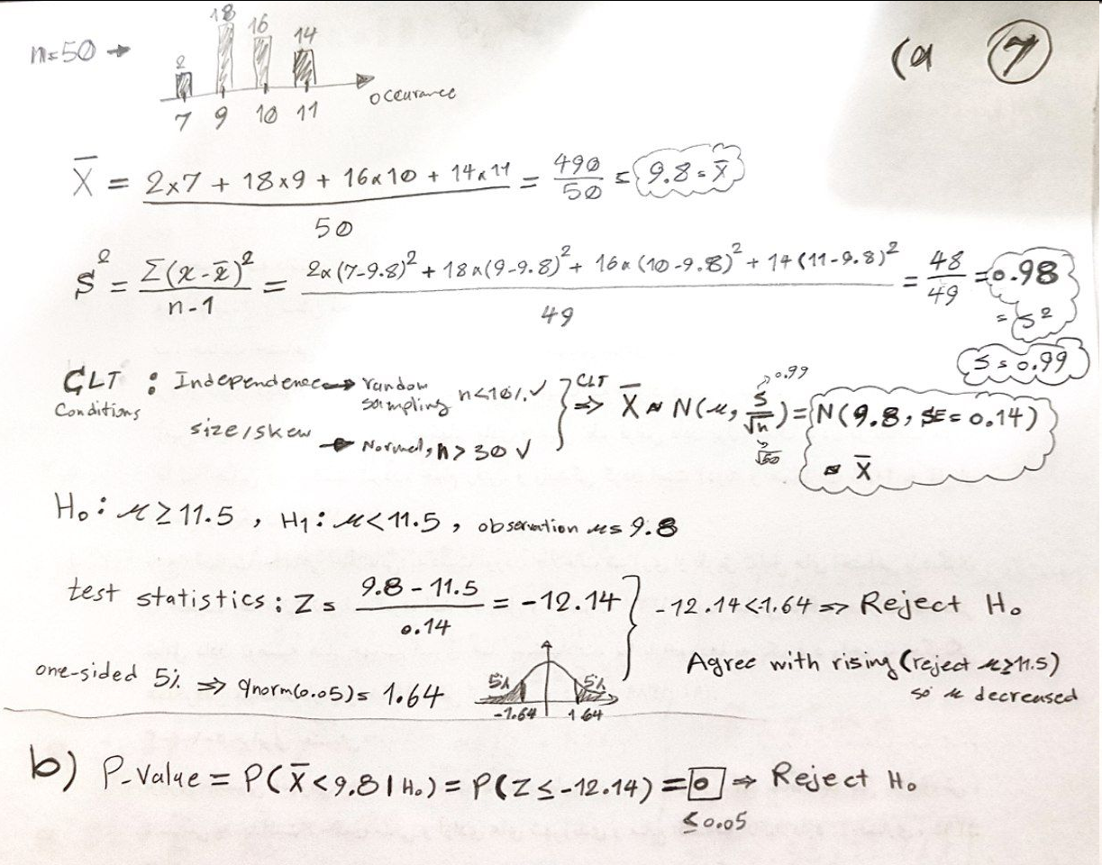

b. What is the p-value for your test?



# Q8

An insurance company wants to audit health insurance claims in its very large database of transactions. In a quick attempt to assess the level of overstatement of this database, the insurance company selects at random 400 items from the database (each item represents a dollar amount). Suppose that the population mean overstatement of the entire database is $8, with a population standard deviation of $20.

a. Find the probability that the sample mean of the 400 would be less than $6.50.

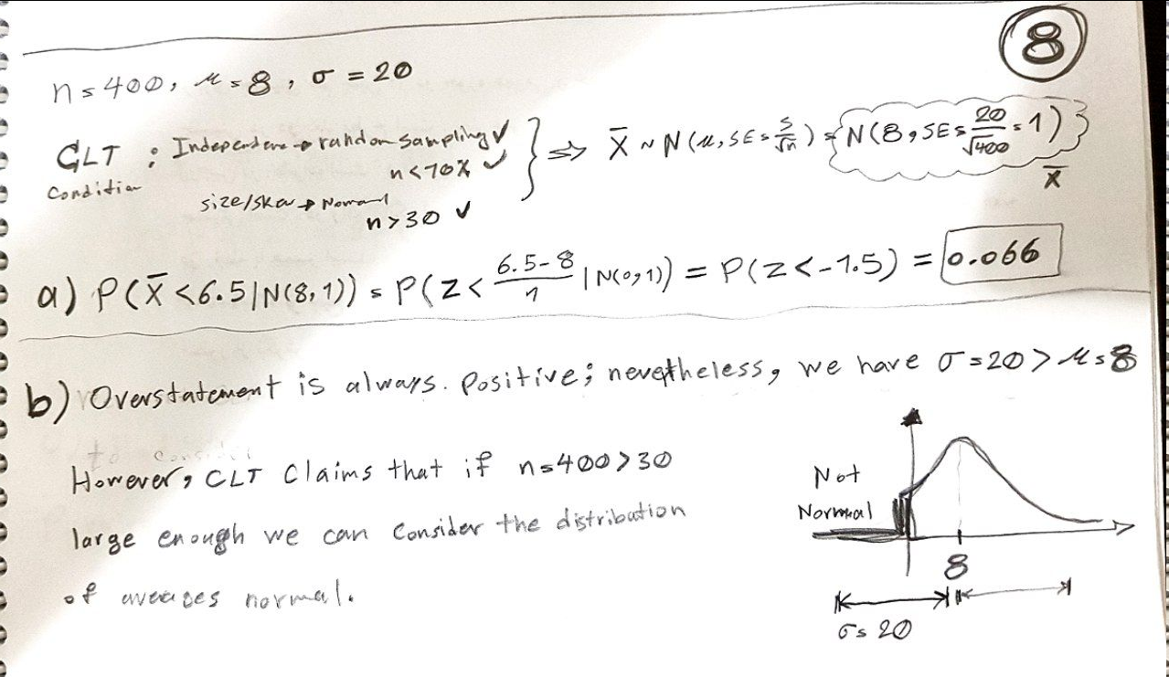

b. The population from where the sample of 400 was selected does not follow the normal distribution. Why?



c. Why can we use the normal distribution in obtaining an answer to part (a)?



d. For what value of ω can we say that P(μ − ω < 𝑋 < μ + ω) is equal to 80%?

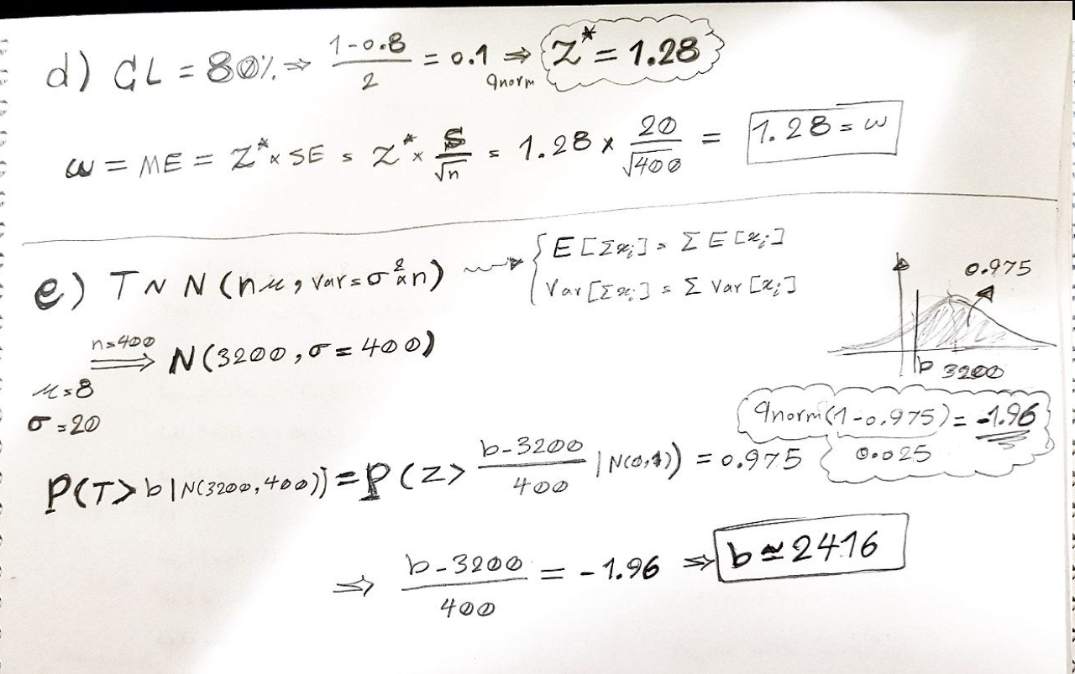

e. Let T be the total overstatement for the 400 randomly selected items. Find the number b so that P(T > b) = 0.975.



# 

# Q9

## (R) According to the patient image dataset1, answer the following questions:

a. Choose two variables (X as numeric & Y as categorical) and construct a 95% confidence interval for the mean of the X column between categories of the Y column. Is there a statistically significant between the means, change X, Y?

X -> age (age of the patient in years)  
Y -> survival (did they survive? Y or N)

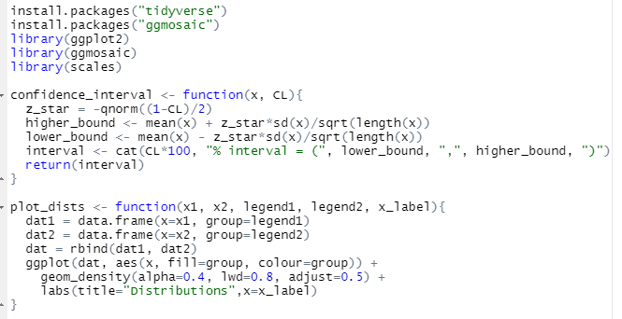

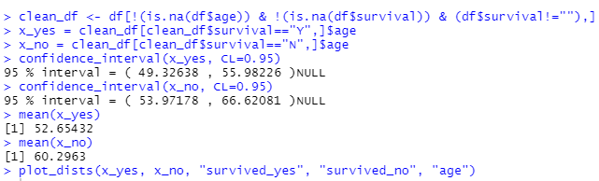

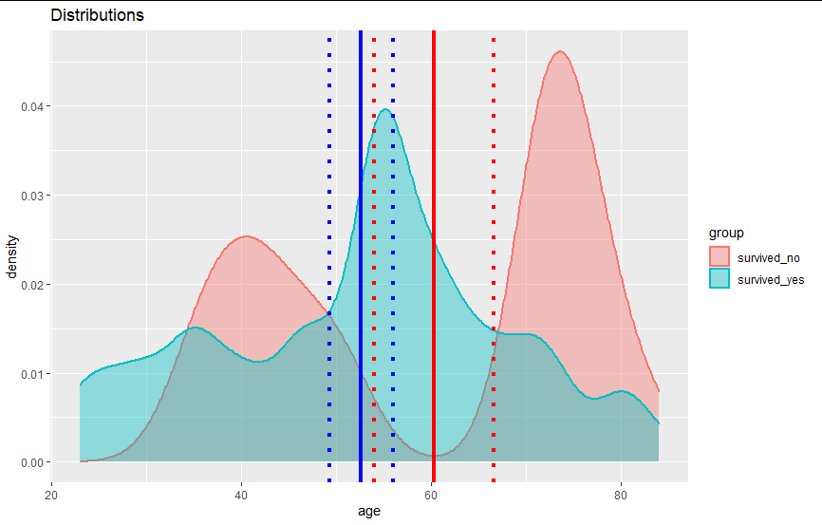

As seen in the printed values and also in the plot, mean of neither one falls in the 95% confidence interval of the other; hence, we reject the null hypothesis and there is statistically significant between the means.

Now we change X, Y

X -> offset (number of days since the start of symptoms or hospitalization for each image, this is very important to have when there are multiple images for the same patient to track progression while being imaged. If a report says "after a few days" let's assume 5 days.)  
Y -> sex (M, F, or blank)

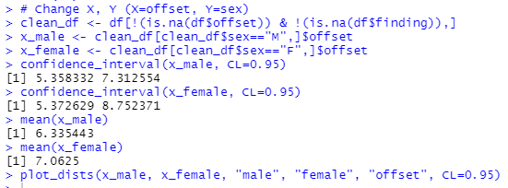

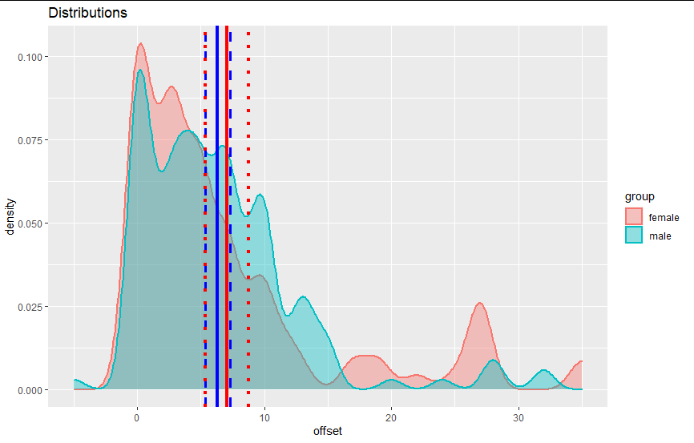

In this case both mean of male falls in female interval and mean of female falls in male interval therefore we cannot reject null and we cannot say there is statistically significant.

b. Choose two variables (X & Y as categorical) and construct a 99% confidence interval for the proportion of the X column between categories of the Y column. Is there a statistically significant between the proportions, change X, Y?

# 

# X -> went_icuYes (Y) if the patient was in the ICU (intensive care unit) or CCU (critical care unit) at any point during this illness or No (N) or Y -> survivalYes (Y) or no (N) or blank if unknown

# 

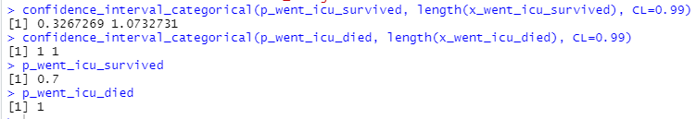

As we can see p of survived does not fall in (1,1) of died (all died were in icu) so we can say there is statistically significance; however the other way meaning p of died falls in interval of survived so we cannot reject in this way.

Change X,Y:

X -> sexMale (M), Female (F), or blank  
Y -> intubated Yes (Y) if the patient was intubated (or ventilated) at any point during this illness or No (N) or blank if unknown.

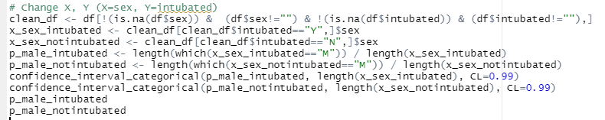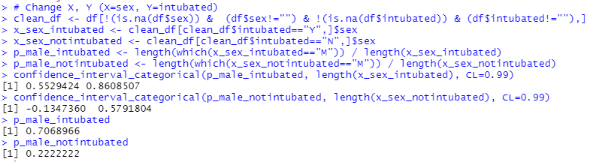

In this data there is statistically significance between sex and intubated as much more male were inturbated and we can see that p is not falling in the other category’s interval in either case.

# Q10

## (R) According to Exercise 7, we are ambiguous about the actual value between 9,10,11,12,13, but we know 𝜎=0.7. Answer the following questions by computing power.

a. When do we use the power curve? What is the ability of that? (explain)

Power of a test is the probability of correctly rejecting 𝐻0, and the probability of doing so is 1 − 𝛽. (𝛽 is the type II error when we must have rejected H0 but we did not.)

Power = 1 − 𝛽 = 𝑃(reject 𝐻0 | 𝜇 = 𝜇𝑎)

This means that what if the 𝜇 = 𝜇𝑎 then what is the probability that we reject H0. The further 𝜇𝑎 from 𝜇, we expect larger power.  
Power curve is plotting power for different 𝜇𝑎.   
Power can be fixed usually about 80% and then we can compute the proper sample size n. Therefore, we need to leverage power to decide sample size in our tests.

b. Draw the power curve of different 𝜇𝑎.

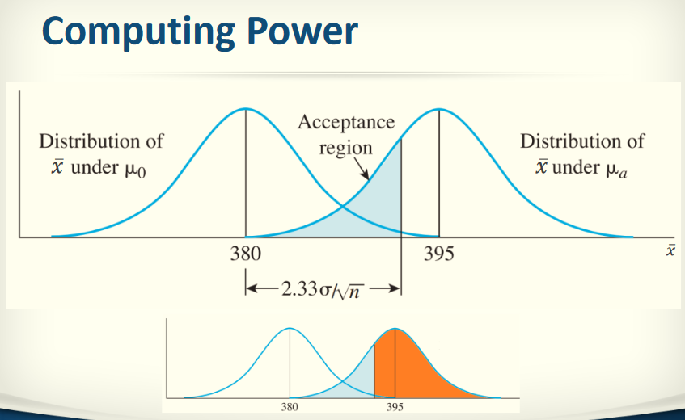

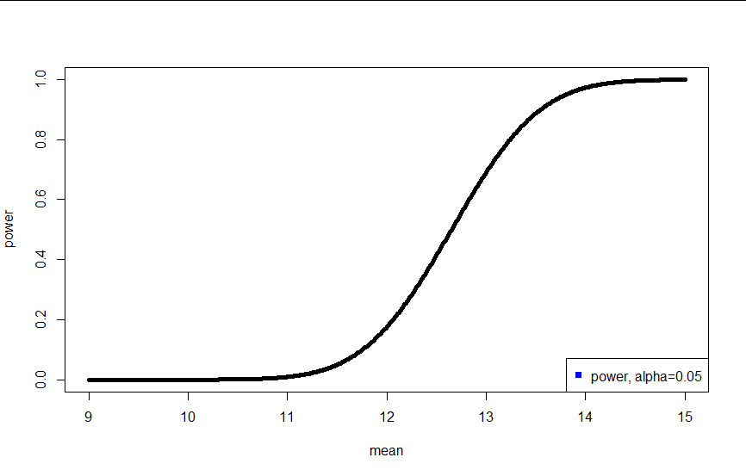

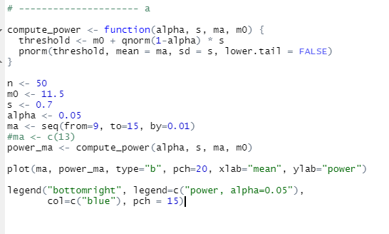

c. Choose the most reliable 𝜇𝑎 and plot distributions of “𝑥̅ 𝑢𝑛𝑑𝑒𝑟 𝜇0” versus “𝑥̅ 𝑢𝑛𝑑𝑒𝑟 𝜇𝑎”. Specify the acceptance region, 𝛼, 𝛽, 𝑝𝑜𝑤𝑒𝑟 on the plot

Power around 80% is reliable, hence we choose 13 with power of 97%.

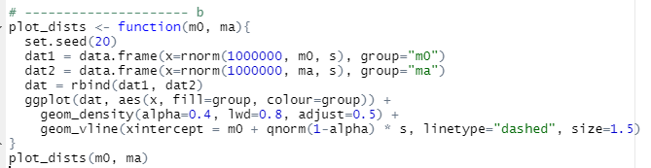

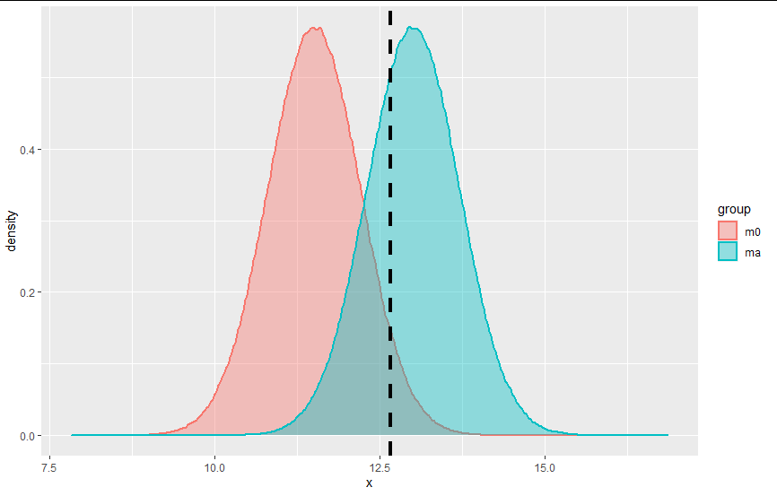

region of ma on the left of threshold is acceptance region, 𝛼 is the region of m0 on the right side of threshold, 𝛽 is the region of ma on the left side of threshold, and power is the region of ma on the right side of threshold.

# Q11

## (Bonus) Answer the following question:

a. Explain “what-if study” and “Double what-if study” with an example.

What if study is comparing the observed results to those you would expect if the intervention had not been implemented - this is known as the 'counterfactual'. Statistically created counterfactuals are developing a statistical model, such as a regression analysis, to estimate what would have happened in the absence of an intervention.

b. List Hill’s nine items and briefly explain each of them.

1. **Strength** (effect size): A small association does not mean that there is not a causal effect, though the larger the association, the more likely that it is causal.
2. **Consistency** (reproducibility): Consistent findings observed by different persons in different places with different samples strengthens the likelihood of an effect.
3. **Specificity**: Causation is likely if there is a very specific population at a specific site and disease with no other likely explanation. The more specific an association between a factor and an effect is, the bigger the probability of a causal relationship.[[1]](https://en.wikipedia.org/wiki/Bradford_Hill_criteria#cite_note-bh65-1)
4. **Temporality**: The effect has to occur after the cause (and if there is an expected delay between the cause and expected effect, then the effect must occur after that delay).
5. **Biological gradient** (dose-response relationship): Greater exposure should generally lead to greater incidence of the effect. However, in some cases, the mere presence of the factor can trigger the effect. In other cases, an inverse proportion is observed: greater exposure leads to lower incidence.[[1]](https://en.wikipedia.org/wiki/Bradford_Hill_criteria#cite_note-bh65-1)
6. **Plausibility**: A plausible mechanism between cause and effect is helpful (but Hill noted that knowledge of the mechanism is limited by current knowledge).
7. **Coherence**: Coherence between epidemiological and laboratory findings increases the likelihood of an effect. However, Hill noted that "... lack of such [laboratory] evidence cannot nullify the epidemiological effect on associations".
8. **Experiment**: "Occasionally it is possible to appeal to experimental evidence".
9. **Analogy**: The use of analogies or similarities between the observed association and any other associations.

c. According to Hill’s nine items, answer the following statements about evidence of cause and effect correspond.

i. On November 9, 2020, Pfizer reported early results from a randomized controlled trial of their coronavirus vaccine based on messenger RNA technology. The report stated that the vaccine appears to be at least 90% effective. To which of Hill’s nine items does this evidence of cause and effect correspond?

**Strength** (effect size): A small association does not mean that there is not a causal effect, though the larger the association, the more likely that it is causal. 90%

And

**Experiment**: "Occasionally it is possible to appeal to experimental evidence".

ii. At the same time, Moderna was developing a coronavirus vaccine also based on messenger RNA technology. Which of Hill’s nine items suggested that the Moderna vaccine would also be effective?

**Analogy**: The use of analogies or similarities between the observed association and any other associations.

iii. Lee and Skerrett (2001) found that higher levels of physical activity are more strongly protective against all-cause mortality. Which of Hill’s nine items does this evidence of causation address?

**Plausibility**: A plausible mechanism between cause and effect is helpful (but Hill noted that knowledge of the mechanism is limited by current knowledge).